STUMP SEATS 101

Stump seats made from reclaimed wood stumps and recycled materials are a fun activity for children and can be set up for the perfect mobile outdoor classroom. Students love rolling out the stumps, cutting vinyl and cushions, and hammering in this hands-on learning activity.

Materials

Any materials that can be found in junkyards, construction yards, the Habitat for Humanity Restore, or other places are encouraged!

-Old wood stumps about 1ft x 1ft or 1.5ft x 1.5ft. A flat top and bottom are optimal for stability
-Vinyl sign material (often sign shops can donate old vinyl signs)
-Closed cell foam (must be waterproof, old yoga mats can be a good source)

Directions

- First knock off any bark from the stump (old stumps are best for this because they have loose bark or no bark at all). Hammer down any sharp burrs as well.
- Cut a piece of foam that fits the top of the stump.
- Cut a piece of vinyl 3 inches larger than the top of the stump all the way around.
- Put foam on top of stump. Cover foam with vinyl. Hammer vinyl around all sides of stump. Be sure to pull vinyl tight. Place nails every 1-2 inches.
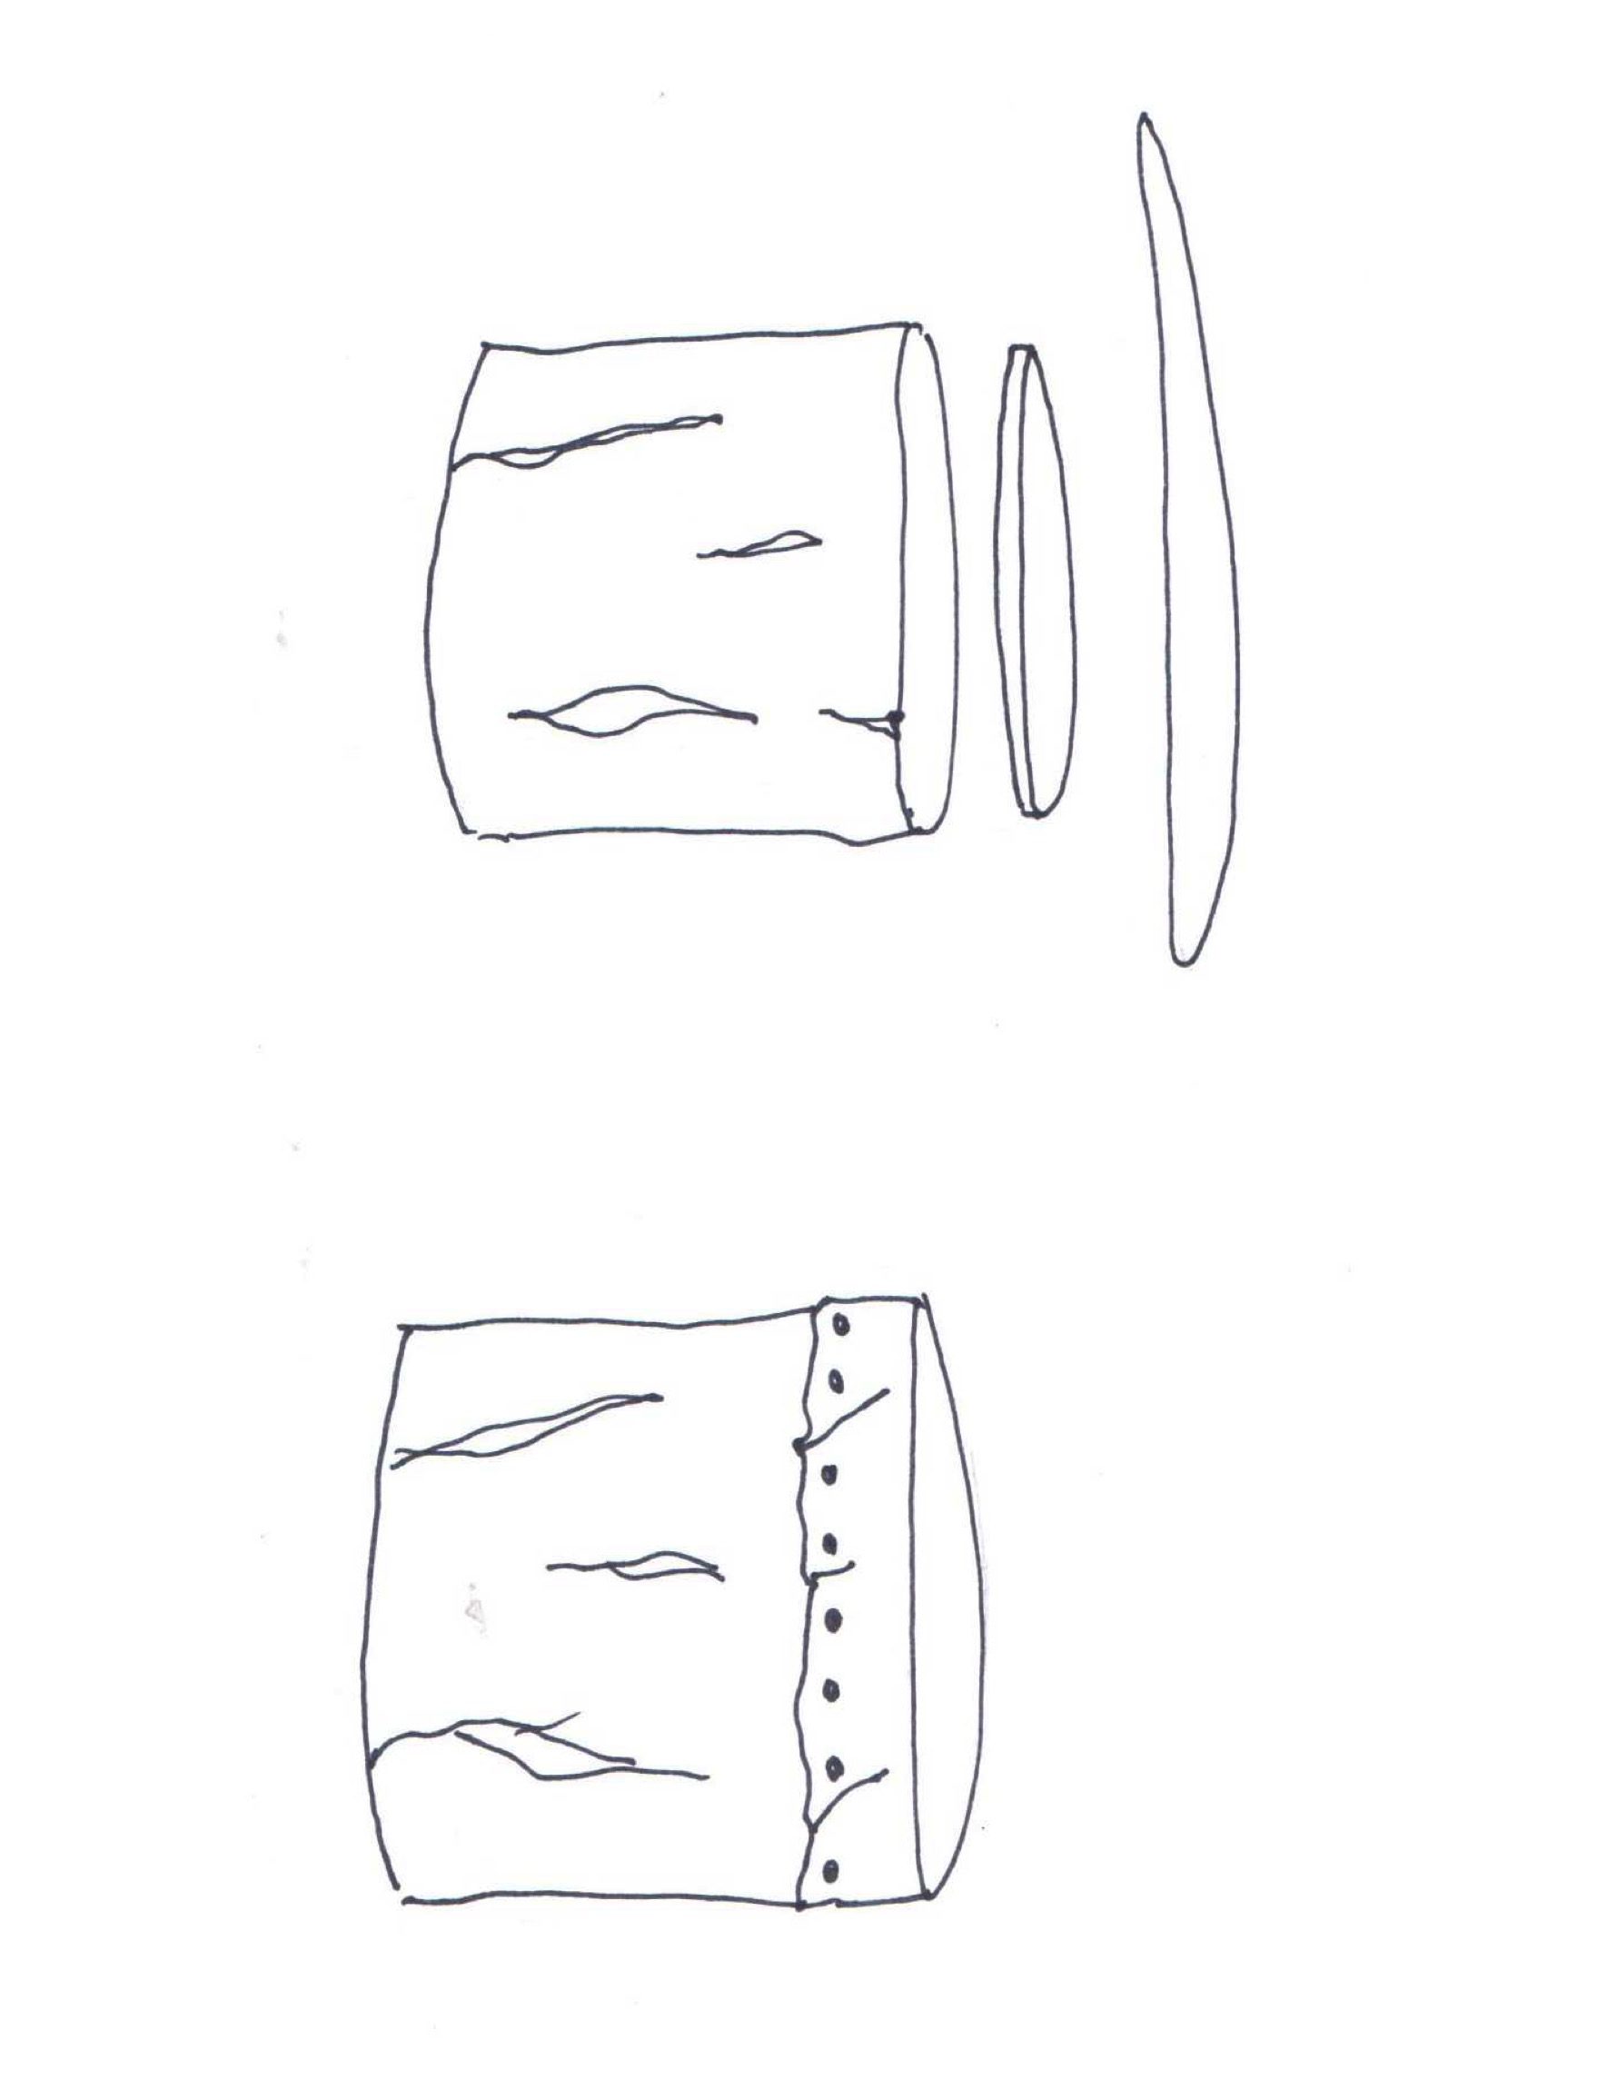
-Store stumps inside or outside under a tarp.
-Roll out stumps and set up for a classroom or outdoor seating.
